# 

# **logo.png**

# 

# **CRISPRBacterial.jpg**

# **Introduction:**

Genetic engineering involves modifying an organism’s DNA to deliberately change an aspect of the organism for a particular purpose. This kit demonstrates the power of the CRISPR Cas9 system by modifying the genomic DNA of a strain of *E. coli* so that it can grow and survive in conditions it normally would not be able to.

This kit requires ~10 hours of work over the course of at least 2 days. It can be completed in a weekend if fresh bacterial cultures are prepared on a **Friday night**.

As this document is constantly being updated with tips and pointers and there are video links embedded, you can find the most up to date version online at: <https://goo.gl/fQYkSX>

# **What is CRISPR Cas9 doing in this experiment?**

Bacteria and all organisms need to make proteins to survive. Proteins are tiny nanomachines that do everything from control our metabolism to keeping our heart beating. In order to make a protein a cell uses the DNA code. Each 3 letters of DNA codes for a single amino acid and proteins are just chains of amino acids.

Proteins(like Cas9) are made by a nucleic acid and protein complex in the cell called the [ribosome](https://en.wikipedia.org/wiki/Ribosome). The media that you are attempting to grow the bacteria on contains a molecule called streptomycin which binds the ribosome and prevents it from making proteins, not allowing the bacteria to replicate and so they can’t grow. This kit makes a specific mutation in the ribosomal subunit protein [rpsL](https://www.wikigenes.org/e/gene/e/947845.html) that prevents streptomycin from binding it and so the bacteria can grow just fine on the media. It changes a single DNA base so that the Lysine amino acids at position 43 (K43) is turned into a Threonine.

The genome of the *E. coli* bacteria that you will engineer is over 4 million DNA bases in size and CRISPR will find the single one that needs to be mutated! This mutation will cause an amino acid change in the ribosomal subunit proteins that are being made.

[For more information on sequences and details check out our more advanced CRISPR guide here](https://docs.google.com/document/d/1F0zYVcIuhWTjmzizaQ7M3UiRLq9M5GpUbP4NXhnKphU/)

# 

# ProtocolFooter.png

# protocoltableofcontents.png

# Kit contents(pg. 3)

# Timeline(pg. 4/5)

# Making Plates[(pg. 6/7/8)](https://docs.google.com/document/d/1JMZmCDhzAtN2FSrjAbxP_FhRK90XbYpE0_PDvRYAKIQ/edit#heading=h.ekponrotise2)

# Making Competent Bacteria[(pg. 9-12)](https://docs.google.com/document/d/1JMZmCDhzAtN2FSrjAbxP_FhRK90XbYpE0_PDvRYAKIQ/edit#heading=h.ekponrotise2)

# DNA Transformation & CRISPR[(pg.13/14)](https://docs.google.com/document/d/1JMZmCDhzAtN2FSrjAbxP_FhRK90XbYpE0_PDvRYAKIQ/edit#heading=h.ekponrotise2)

# Successful experiment example[(pg. 15)](https://docs.google.com/document/d/1JMZmCDhzAtN2FSrjAbxP_FhRK90XbYpE0_PDvRYAKIQ/edit#heading=h.ekponrotise2)

# How to Create your own gRNA (pg. 16)

# ProtocolFooter.png



1 - LB Agar

1 - LB Strep/Kan/Arab Agar (Kan (25 µg/ml), Strep (50 µg/ml) and Arabinose (1mM))

1 - 250 mL glass bottle for pouring plates

1 - 10-100uL variable volume adjustable pipette

1 - Box 1-200uL Pipette Tips

14 - Petri Plates

1 - Microcentrifuge tube rack

Inoculation Loops / Plate spreader / Pairs of Nitrile Gloves in plastic bag

25 - microcentrifuge tubes

5 - 1.5mL microfuge tubes containing LB broth

1 - 50mL centrifuge tube for measuring liquid volume

1 - 1 mL bacterial transformation buffer 25mM CaCl2, 10% PEG 8000

**Perishables**

*Ok to be shipped at RT but upon arrival should be stored in the freezer for longer-term*

55uL of 100ng/uL - Cas9 plasmid Kanr

55uL of 100ng/uL - gRNA plasmid Ampr

55uL of 1mM- Template DNA

Sequence: ATACTTTACGCAGCGCGGAGTTCGGTTTTGTAGGAGTGGTAGTATATACACGAGTACAT

*Ok to be shipped at RT but upon arrival should be stored in the fridge for longer-term*

Non-pathogenic *E. coli* bacteria





**Preparation**

* 1 hour Make plates (set aside more time if it's your first time making plates)
* streak out bacteria onto an LB Agar plate (takes ~1 min)
* 12-18 hours Let the bacteria grow (easiest to just let it sit overnight)

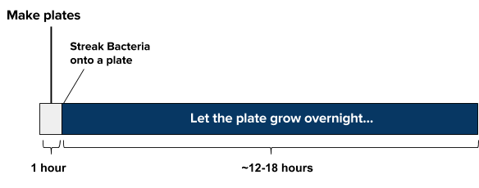

**Day of experiment**

* Mix together sample, plasmids, and transformation mix (takes ~5 min)
* **30 min** refrigerate sample solution (do NOT freeze)
* **30 seconds** ‘heat shock’ the sample warm (42ºC/108ºF) water. Add LB media to your cell solution (takes ~1 min) incubate for at least 1-2 hours at 30C, (or if at room temp, incubate for at least 4 hours for best results) Plate 200uL of the bacteria solution and let dry for 10 minutes

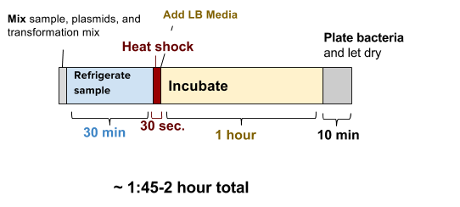

**Incubate and wait for growth**

* ~24 hours Incubate the plate at 30ºC (86ºF) for 16-24 hours or room temperature for 24-48
* hours.



# ProtocolFooter.png

**STOP AND READ BEFORE YOU PROCEED**

# **The most common error we see is improper pipette technique! You must read and follow this pipetting tutorial before you start.** <https://goo.gl/nrA8hT>

This is 10uL of liquid in a pipette tip. The DNA should not have a color we used a dye to make the liquid easier to see. The liquid should go up to the first demarcation on the tip. Make sure you can accurately draw up 10uL into the pipette before you proceed.

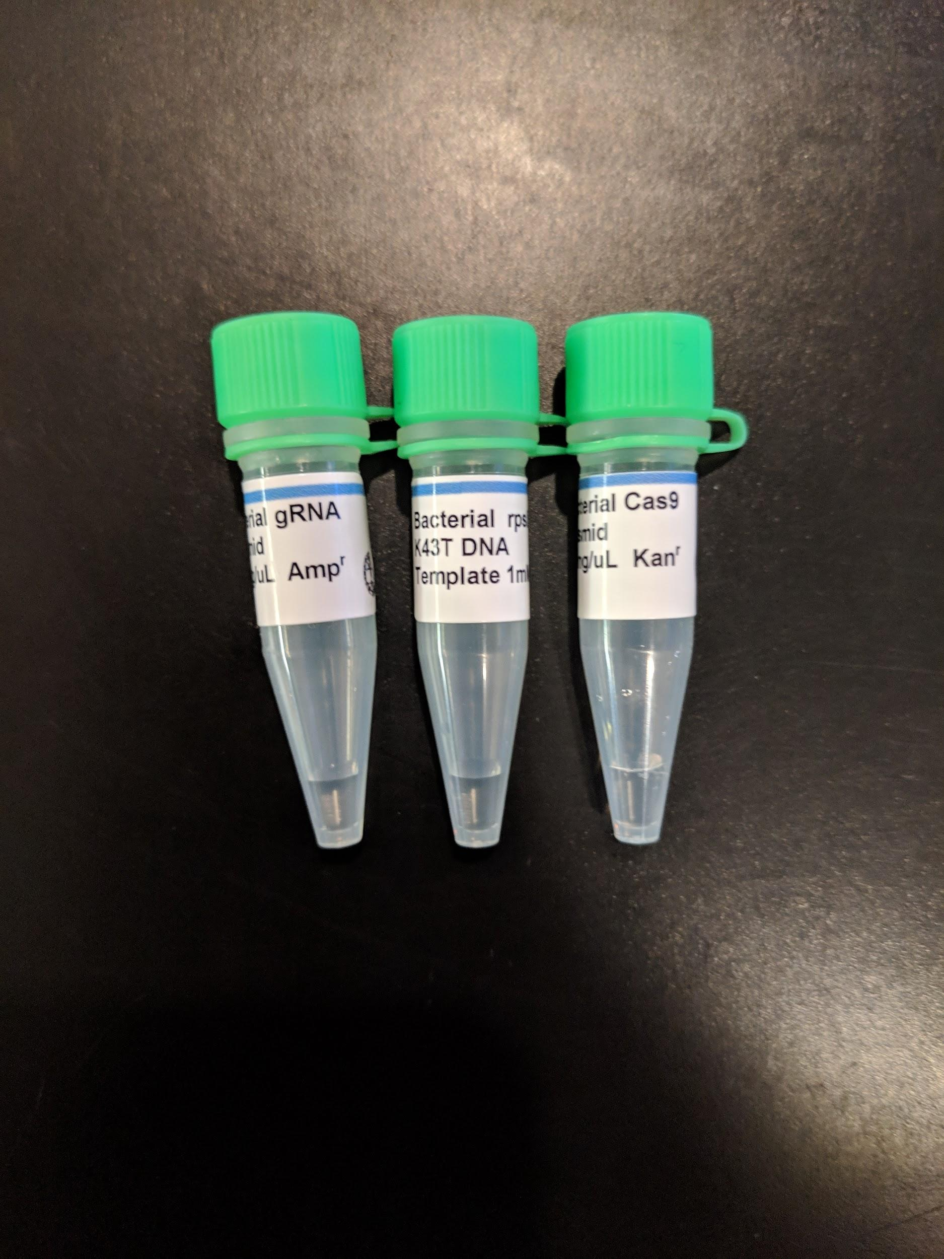

Please check your tubes of DNA. Make sure you flick the liquid to the bottom of the tube by flicking your wrist with tube in hand. If the DNA looks less than that in the picture above take a picture and contact us immediately. If you contact us after the experiment to say there was not enough DNA in the tubes we are sorry but cannot help you without a picture.

# **Bacteria in this kit are non-hazardous and non-pathogenic(cannot cause disease). You can dispose of them by putting 5% bleach on the plate and then putting them in the trash.**

# ProtocolFooter.png

# **protocolandwalkthrough.png**

# **Making Plates (~1 hour, maybe more time if it’s your first time)**

Step by step walk-through with photos at:<https://goo.gl/7yzpA1>

Agar plates provide a solid media nutrient source for bacteria and yeast to grow on. The standard media that is used is LB (Luria Broth, Lysogeny Broth, or Luria Bertani Broth). This contains a carbon source, a nitrogen source, and salt (many strains of bacteria like salt!).

The top part of the full plate has the larger diameter.

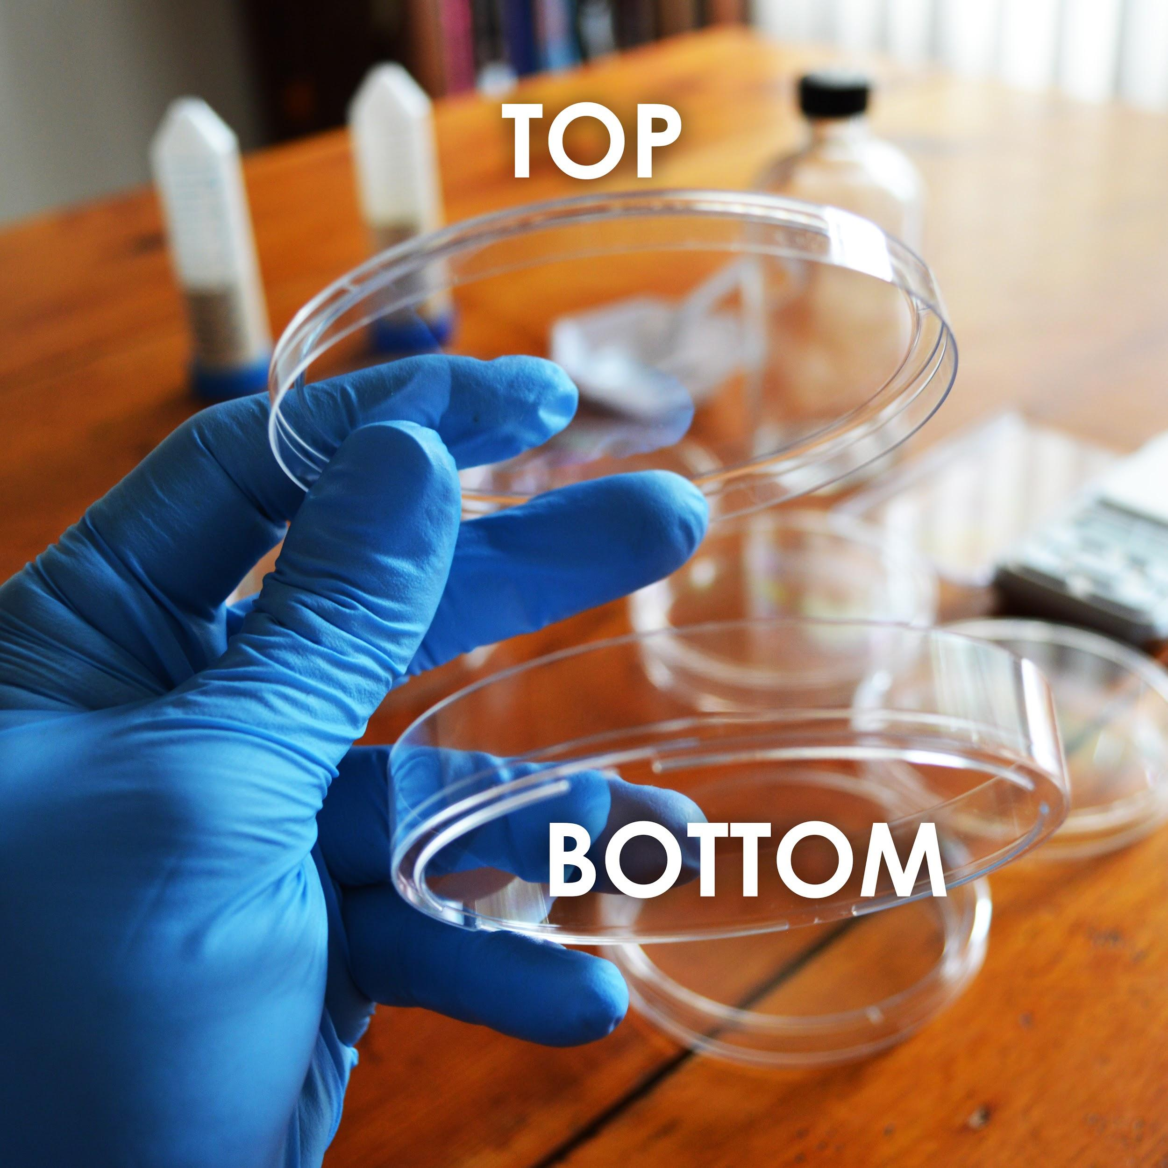

# ProtocolFooter.png

**Making Plates**

1. Take a tube labelled Agar media, such as “LB Agar Media”, “LB Strep/Kan/Arab Agar Media”(For final growth test) or similar and dump its contents into the 250mL glass bottle. (You will need to make plates out of each kind of media, so start with whichever tube of media you choose.)
2. Using the 50mL conical tube labelled “For Measuring Water”, measure and add 150mL of water to the glass bottle.
3. Making agar is like making jello-- heat the agar to dissolve it, then it will solidify when it cools. Heat the bottle in the microwave for 30 seconds at a time, being careful not to let the bottle boil over. DO NOT SCREW THE LID DOWN TIGHT! (just place it on top and give it a slight turn)
4. You will know it’s done when the liquid looks yellow. This should take about 2 -3 minutes total of microwaving. Take the bottle out(caution contents hot) and let it cool until you are able to touch it without much discomfort. This will take 20-30 minutes.
5. While the bottle remains somewhat warm, pour the plates. One at a time, remove the lid of 7 plates and pour just enough of the LB agar from the bottle to cover the bottom half of the plate. Put the lid back on.

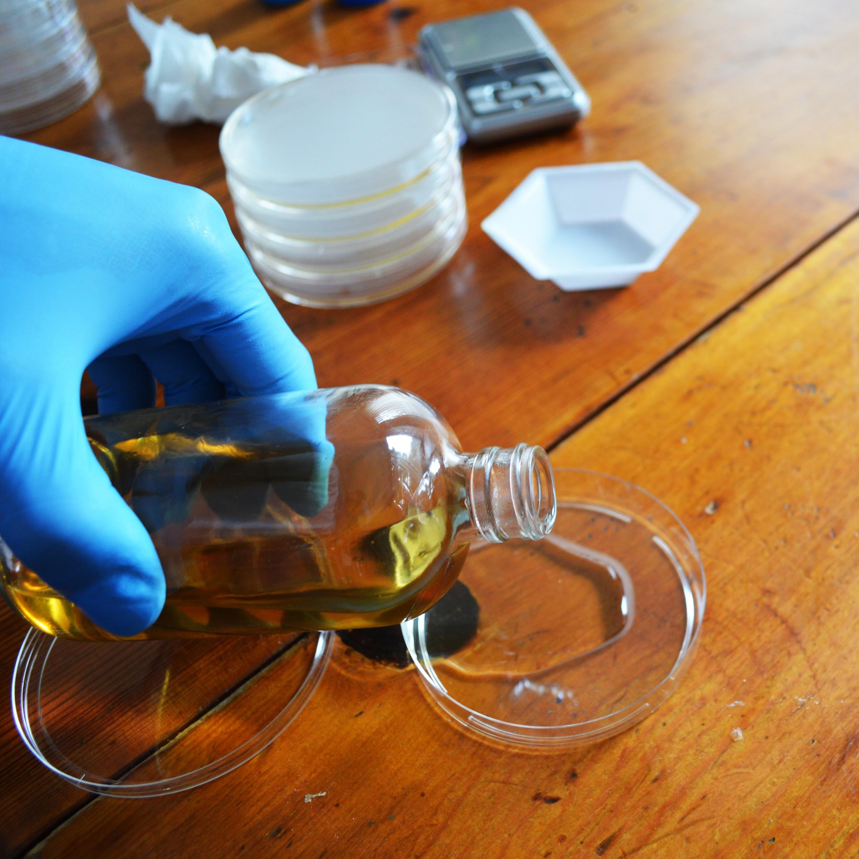

# ProtocolFooter.png



**Making Plates**

1. Let cool for at least one 1 hour before use(you can cool faster by putting them in the fridge but don’t freeze). If possible let the plates sit out for a couple hours or overnight to let the condensation evaporate. Then store in your fridge at 4ºC upside down so any condensation doesn’t drip on the plates.

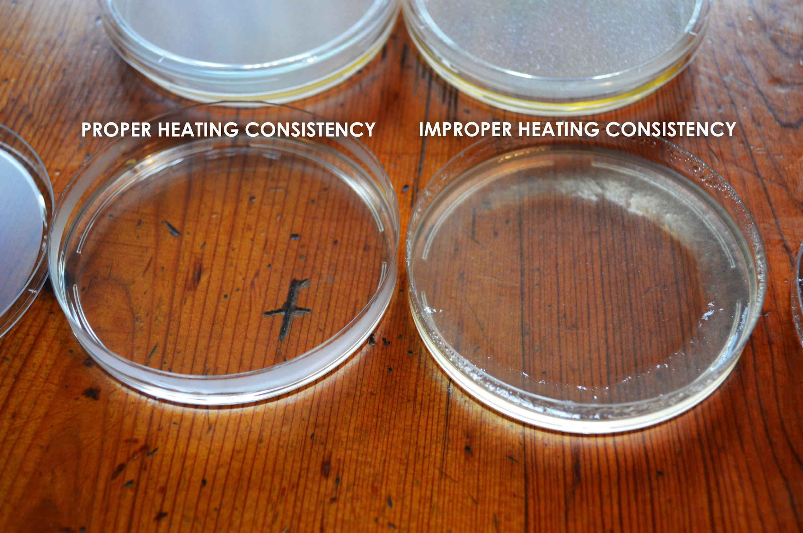

## 

# ProtocolFooter.png

## **protocolandwalkthrough.png**

## **Making Competent Bacterial Cells for Transformation**

‘Competent’ means the bacteria or yeast cells are able to intake foreign DNA. The cells’ walls *normally* prevent things from entering in, but we are going to mix the bacteria with chemicals and salts that change this. In order to get CRISPR to work inside the bacterial cells we need to get all of the components inside the cells! This process is called ‘transformation.’ We put all the materials into synthetic DNA and then trick the bacteria into thinking that our DNA is its own DNA and so they make the Cas9 protein, and the gRNA.

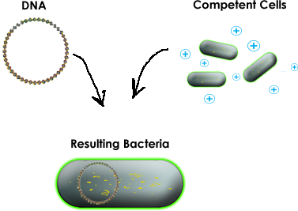

# ProtocolFooter.png



## **Making Competent Bacterial Cells for Transformation**

**The bacterial transformation mix contains:**

**10% Polyethylene Glycol(PEG) 8000**

PEG 8000 is thought to play several different roles in transformation, though nobody really knows for certain. Since both DNA and cell walls are negatively charged, they reject each other. PEG 8000 is thought to function by shielding the charge of the DNA, thereby making it easier to permeate the cell wall. PEG 8000 is also thought to help transport the DNA into the cell, as well as make the cell membrane itself more porous.

**25mM Calcium Chloride(CaCl2)**

Similarly to PEG 8000, CaCl2 is thought to shield and neutralize the negative charge of DNA, thereby making it more likely to enter into the cell.

An agar stab is when someone takes an inoculation loop, puts bacteria on it and then stabs it into a tube full of agar. This method and process is used because it allows easy and safe longer-term storage as compared to a plate.

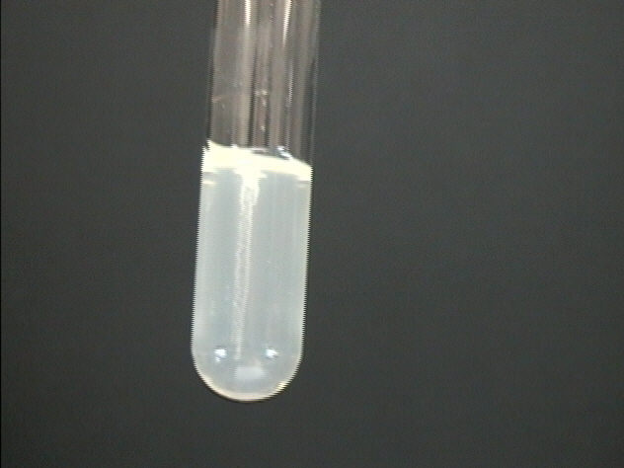

This is a picture of a stab. In your stab you should see a similar whiteish line in the middle of the tube that contains bacterial growth. If you are having a hard time seeing the stab hold it up to the light.

In order to access the bacteria, use an inoculation loop and try and stick it along the same line as the stab. Then take the loop and gently streak it along a plate or use it to make a liquid culture.

# ProtocolFooter.png



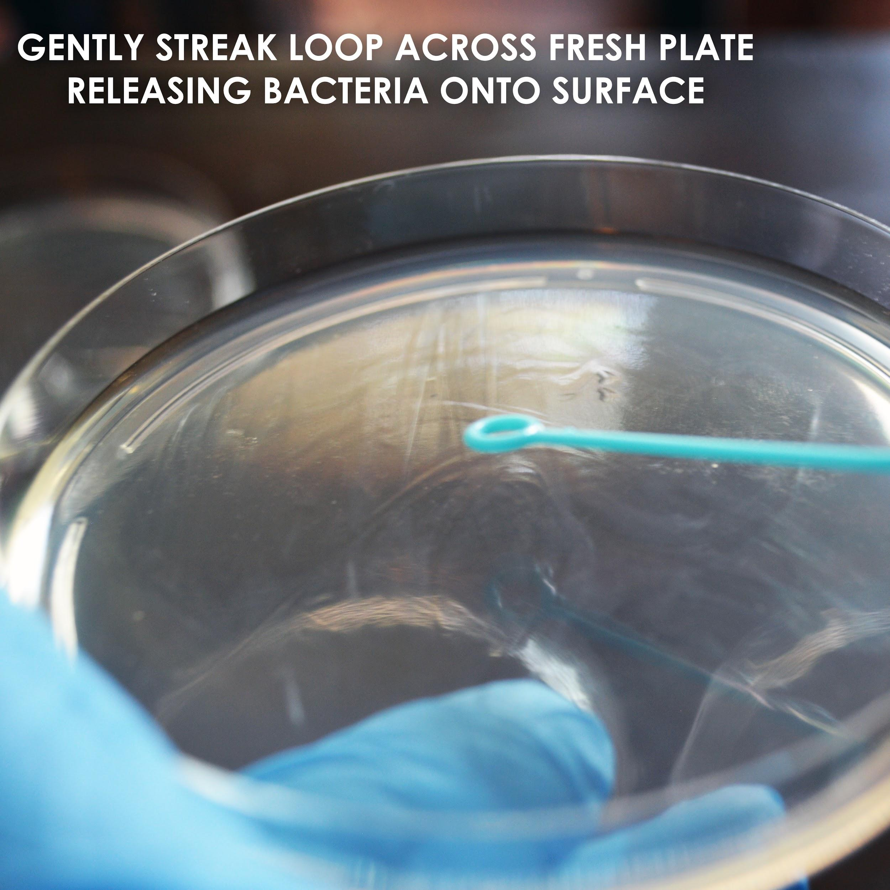

1. Use an inoculating loop to gently scrape out the bacteria and spread it onto a new LB Agar plate. Let the plate grow overnight ~12-18 hours, or until you see white-ish bacteria begin to grow. Make sure you are using the LB agar plate, NOT the LB Strep/Kan/Arab agar plate. See the following link for a walk-through of how to streak out bacteria:<https://goo.gl/GR8IOf>
   1. Note: avoid placing the plate in areas that are cold or the bacteria will grow slowly. Consistent and warm temp. locations are preferable.
   2. Your bacterial plate can be stored in the fridge for a week. However, having fresh bacteria for a transformation greatly increases the likelihood that your experiment will work.

# ProtocolFooter.png

## **Making Competent Cells for Transformation(continued)**

1. Pipette 100uL of Transformation mix to a new microcentrifuge tube.

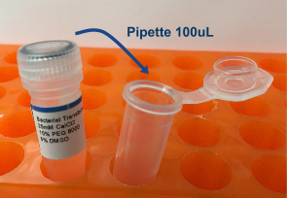

1. Using an inoculation loop, gently scrape a little bacteria off of your fresh plate until the loop is filled, and mix it into the transformation mix. Mix until any big clumps have disappeared. This might require gently pipetting the mixture up and down. Your transformation mix should be cloudy but not quite opaque in the tube i.e. you should be able to see through the mixture. Make one tube for each CRISPR experiment you plan to perform in the next day or two and store them at 4ºC (39ºF) in the fridge if you are not immediately performing the experiment. We suggesting attempting one experiment at a time which gives you multiple opportunities to repeat the experiment.

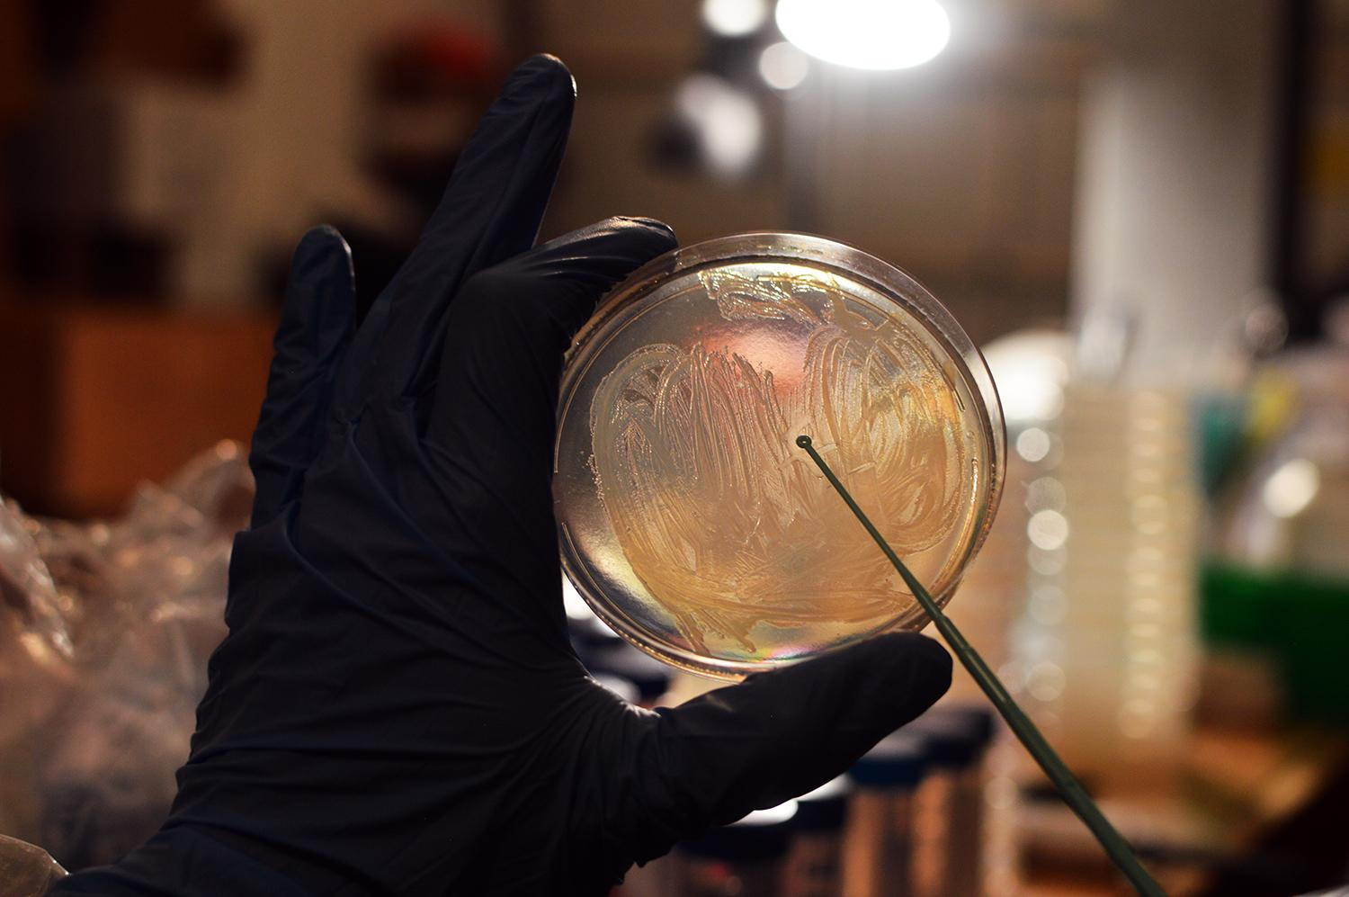

# ProtocolFooter.png



Watch this Video about CRISPR - it will help you understand how it works: <https://www.youtube.com/watch?v=2pp17E4E-O8>

### **CRISPR Has 3 Main parts**

### **Cas9 Protein**

The Cas9 protein is the engine of CRISPR. It binds the gRNA and also the gene targeted for editing. If a gene match is found, the Cas9 protein will cut the the DNA. The cell responds to the cut by trying to repair the DNA damage. Cas9 cuts, it DOES NOT do any actual gene editing. Instead, it tricks the

cell into doing it.

**guideRNA (gRNA)**

The gRNA is combination of the trans associated CRISPR RNA (tracrRNA) and the CRISPR RNA (crRNA), connected by a small nucleotide linker. Some people use the separate tracrRNA and crRNA in the DIY Bacterial CRISPR kit we will use a gRNA. The tracrRNA part of the gRNA binds to the Cas9 protein and to the crRNA. The crRNA part of the gRNA binds to the tracrRNA in order to connect to the Cas9 protein. Critically, the crRNA part of the gRNA also matches (is complementary to) the DNA in the genome that we want to edit. This crRNA match is how the Cas9 protein recognizes the gene to cut.

**Template DNA**

Once the Cas9 protein makes a cut on the gene we want to edit, the cell begins to try and repair the DNA through a process called Homologous Recombination. During this repair process, the cell is looking for a DNA template to figure out how to fill in the gene that was cut. If we flood the cell with a template that is similar to the missing region, but has a mutation or change in it, the cell will mistake it for a true copy and use it instead. Our template DNA has a single base change from an Adenine (“A”) to a Cytosine (“C”). This change causes the DNA to code for a Lysine instead of a Threonine in an important protein. This change prevents Streptomycin from binding to and disabling the protein, which allows the bacteria cell to grow on media containing it.

**Steps of the CRISPR Reaction**

1. Cas9 binds the gRNA molecule
2. The Cas9/gRNA complex finds the DNA sequence that matches the gRNA
3. Cas9 cuts the DNA
4. The cell’s repair machinery fixes the break and using our supplied template
5. Cell has a new DNA sequence

# ProtocolFooter.png



(To Load DNA droplets to bottom of tube hold by closed cap end and flick wrist and elbow)

1. Find the DNA tube labelled “Cas9” and, using your pipette, add 10uL to your competent cell mixture. Change out the pipette tip for a new one.
2. Find the DNA tube labelled “gRNA” and, using your pipette, add 10uL to the same competent cell mixture that you added the Cas9 to. Change pipette tips.
3. Find the DNA tube labelled “Template DNA” and, using your pipette, add 10uL to the same competent cell mixture that you added the Cas9, and gRNA to.
4. Incubate this tube in the fridge or on ice (DO NOT FREEZE) for 30 minutes.
5. Incubate the tube for 30 seconds in 42ºC (108ºF) water. You can approximate this temperature by using water that is warm, but comfortable enough such that you can still keep you hand in it.
6. Add 1.5mL of room temperature water to one of the LB media microcentrifuge tubes and shake to dissolve the LB.
7. Using the pipette, add 500uL of LB media to your competent cell mixture containing your DNA.
8. Incubate the tube at 30ºC(86ºF) for 2 hour or 4 hours at room temperature. This step allows to bacteria to recover and replicate the DNA and perform the CRISPR engineering process _DON’T_ Skimp on the time, this step is key for the experiment to work. If you are having trouble with your experiment increasing this incubation time up to 12 hours will increase the chances of experimental success. Take a LB/Strep/Kan/Arab plate out of the fridge and let it warm up to room temperature.
9. Using the pipette, add 200uL of your CRISPR transformation mixture on top of an LB Strep/Kan/Arab Agar plate.
10. Using an inoculation loop, gently spread the bacteria around the plate and let dry for 10 minutes before putting the lid back on.
11. Flip the plate upside down to prevent condensation from forming and dripping onto your bacteria.
12. Incubate the plate at 30ºC (86ºF) for 16-24 hours or room temperature for 24-48 hours.
13. If you begin to see little white round dots growing, then your CRISPR genome engineering experiment was a success! If not, give it another shot, Science doesn’t always work on the first try. Also, feel free to contact us at odin@the-odin.com and we will help you troubleshoot.

# ProtocolFooter.png

## **DNATRANSCRISPR.png**

## **Successful experiment example...**

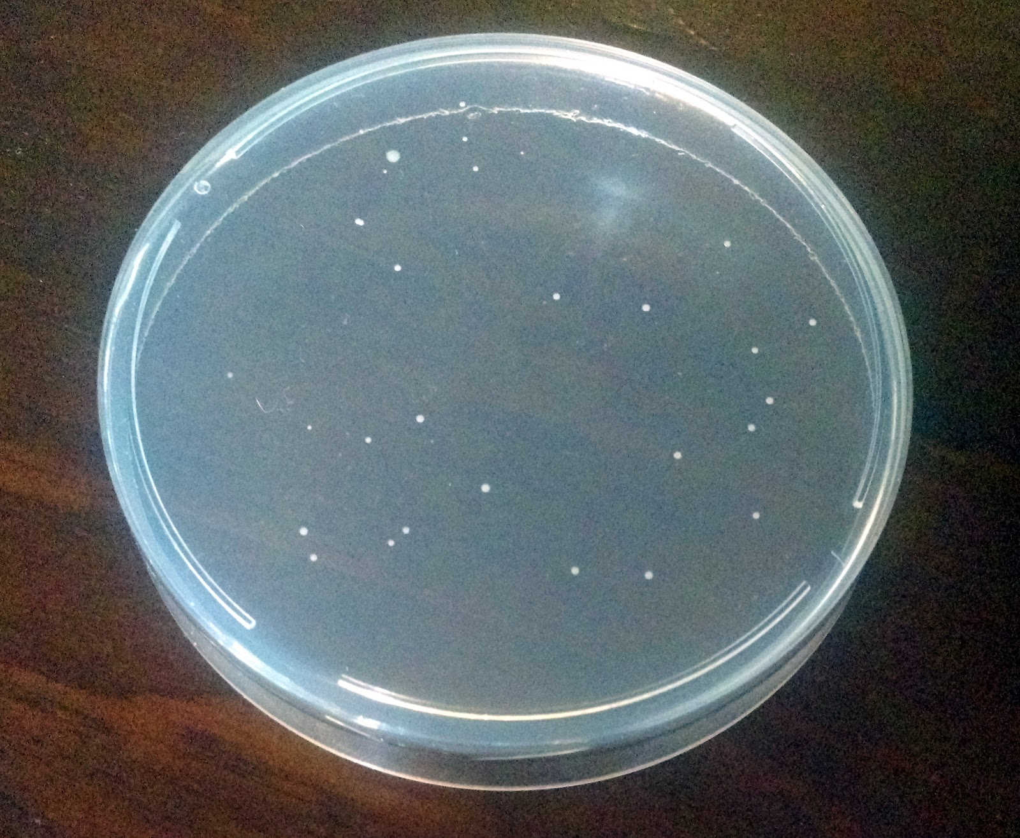

In a successful experiment you should see whitish or yellowish bacteria growing on the plate as seen in the picture. These are bacterial colonies that were successfully edited and so they survived and replicate to form what scientists call colonies, or small groups of bacteria.

# 

# ProtocolFooter.png

## **How To Create Your Own gRNA**

In order to do your own CRISPR experiment the only you need to know is how to design your own gRNA. The gRNA tells the Cas9 protein where to cut and so matches the gene that you want change. The only requirement is that the gene have two guanine(G) nucleotides or two cytosine(C) nucleotides next to each other. This is referred to as the PAM or Protospacer Adjacent Motif and is indicated by the sequence NGG or CCN where “N” means any nucleotide. The lucky thing is you don’t need to do this yourself as there are websites that can chose for you!

1. Goto <http://chopchop.cbu.uib.no/>
2. For **In** chose *E. coli* str. K12/MG1655
3. For **Target** chose rpsL the gene modified in this experiment
4. What you will see is a ranking of gRNAs based on how unique they are(so other places in the genome aren’t accidentally cut) and also other properties that make good gRNA
5. Our gRNA sequence in this experiment is GGAGTTCGGTTTTTTAGGAG. If you search it is ranked #14. So why choose the #14 ranked gRNA? In our case, we chose this gRNA because it is so close to the position in the gene that we want to change the DNA. This increases the likelihood that the template DNA will be inserted into the genome. If you are just trying to knock-out a gene it is best to choose the best gRNA that occurs earliest in the gene. In this case we would probably choose #6(earliest) or #1(best and still early).
6. If you have an *E. coli* bacterial gene that you want to target for knock-out you can order custom gRNAs on our website: [http://the-odin.com/custom-crispr/](http://www.the-odin.com/custom-crispr/)
7. You can use these same methods to design a gRNA for other organisms. Instead of E. coli just enter the organisms name and chose a gene. For instance, myostatin knock-outs in animals make them very muscley. You can find a gRNA that would target the MSTN or myostatin gene in humans.

# ProtocolFooter.png

# ProtocolFooter.png

## **Check Us Out Online**

<http://twitter.com/TheODINInc>



<http://youtube.com/c/TheODINInc>



<http://facebook.com/TheODINInc>

# ProtocolFooter.png

# 

# 

# 

# 

# 

# 

# 

# 

# 

# 

# 

# 

# 

# 

# 

# 

# 

# 

# 

# 

# 

# 

# 

# 

# 

# ProtocolFooter.png